UnSplash   
Photos Web Portal

Use Case

**Version 1.0**

July 31, 2020

Notice of Proprietary Property

The information contained herein is the property of Girmiti Software Private Limited the possessor agrees to maintain this document in Confidence, not to reproduce, copy, reveal or publish it in whole or in part



#2/3, SLV Plaza, Arvind Avenue,

Kundalahalli Gate, Marathahalli, Bangalore 560037

India

Table of Contents

1 Introduction 3

1.1 Audience 3

1.2 Requirements 3

2 Use Cases 4

2.1 Search Photo 4

2.1.1 Sequence Diagram 5

2.2 Collections 6

2.2.1 Add to Collections 6

2.2.1.1 Sequence Diagram 8

2.2.2 Edit Collections 9

2.3 Module: Favorites 11

2.3.1.1 Sequence Diagram 13

2.4 Download Photo 14

Document History

|  |  |  |  |  |
| --- | --- | --- | --- | --- |
| **Version** | **Submitted Date** | **Prepared by** | **Reviewed by** | **Revision History** |
| 1.0.0 | 31-07-2020 | Ashish | Jom George | Initial Draft |
|  |  |  |  |  |
|  |  |  |  |  |
|  |  |  |  |  |

# Introduction

This document describes the use cases for user to open web application.

## Audience

This document is for the development and QA team to review the use case features of the Unsplash image web services.

## Requirement

## Coding Challenge :: Images Search App

## Implement an Interface that allows users to to search for images using any FREE images search API such as:

## Unsplash

## Flickr

## The results should be updated live as the user type into the search box:

## Each image display some information when hover:

## Link to author page

## A button to save the image to the user’s favorite page.

## When click, show a pop up for the user to choose which list to add the image to.

## If there’s no list, allow the user to create a new list

## On the Favorite page:

## Display all lists with correct images in each list

## Edit list title & description

## Click on each image should trigger the download.

## Rquirements

## Use any version of Angular

## Use `ngrx/store` for state management

## Use `ngrx/effect` for handling side effects

## Use any CSS preprocessor of your choice

## The project should include a README file

# Use Cases

## Search Photo

| **Title** | **Search Photo** |
| --- | --- |
| **Use Case ID** | SPH-0001 |
| **Actors** | A user with appropriate privilege |
| **Pre-conditions** | 1. User opens website 2. By Default, the home screen is displayed |
| **Description** | This use case shall enable the user search of the image by keying in the desired keyword |
| **Use case trigger** | 1. By Default, the home screen is displayed 2. The home screen shall have the following options    * Search Photos    * Your personal Menu for favorite navigation    * Home    * Pagination 3. On hover the photo    * Option to add favorite    * Link to author page |
| **Main flow / Flow of Events** | 1. User enters the text into the search box. 2. User shall either “Enter” after typing the desired keyword or shall choose from the displayed Keyword list 3. Based on the keyed in text, search result shall be displayed on the page |
| **Sub-flow/Alternate Flows/ Scenarios** | 1. Once the search results are displayed, user can hover over the image which shall have the following options and details    * Add to Collection (button)    * Author information (view only) |
| **Assumptions** | None |
| **Post-conditions** | User is able to search the desired photo based on the keyword |
| **Status** | Open |
| **Issues** | None |
| **Business Rules** | 1. If no results are available for the searched keyword, the page shall display “No photos Found” message 2. The search result displayed on the screen shall be based on the unsplash api |

### Sequence Diagram

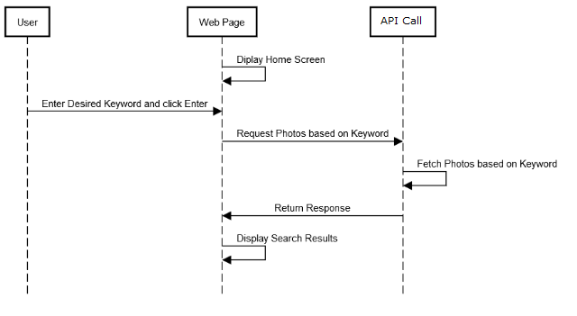

## Collections

### Add to Collections

| **Title** | **Add to collections** |
| --- | --- |
| **Use Case ID** | UIS-0001 |
| **Actors** | Who has the privilege to access the application. |
| **Description** | This use case shall provide the access to the user to search the image and add the image as user’s favorite. |
| **Pre-conditions** | User opens the application |
| **Use case trigger** | 1. Initially, user opens the application |
| **Main flow / Flow of Events** | 1. Once the user enters the text into the search box, the application shall have the following option to choose:  * Search box shall display the suggestion for the user selection. * User clicks the ‘Enter’ button or can click on Search icon. * Application shall display the list of images of the searched text with the name of the searched text  1. Each image shall have the following option to view and choose when user mouse hover on the image:  * Option to add the image as user’s favorite. * Name of the author (Clicking on author name triggers navigate to author profile page) * Navigation link fro author  1. In an image, when user click “’+’ option (Add as favorite)” option, and application shall display a popup with the below options to view and choose:  * Selected Image <In the left side of the popup> * Add to Collection <Non-editable heading> * Create a new collection <option> * List of already created/added collections name with ‘+’ option in the right to add the selected image in the collection.  1. On clicking the option - 'Create a new collection', application shall display an option – 'create a new collection' with below options in order to create new collection:  * Name * Description (optional) * Create collection <Button> * Cancel <Button>  1. User fill the fields of ‘Create a new collection’. 2. Click the ‘Create collection’ button 3. User select the collection or click ‘+’ option from the list |
| **Sub-flow/Alternate Flows/ Scenarios** | 1b. User can select an option from the displayed suggestion  1c. The suggestion displayed of the entered text in the search box is in alphabetical order.  1d. Application is unable to display the suggestion.  1e. When user enters junk values in the search box and clicks enter, application is unable to provide any result.  2a. Application is unable to display the list of images of the searcher text.  3a. When user mouse hover on an image, application is unable to display the ‘add to favorite’ option.  3b. When user mouse hover on an image, application is unable to display the ‘Name of the author'  3c. When user mouse hover on an image, application is unable to display the ‘Image of the author'  3d. On clicking the ‘download photo’ option, application shall download the photo into the device (Desktop, laptop, mobile)  4a. When user clicks '’+’ option (Add as favorite)' option, application is unable to navigate to the next page to display the adding options.  4b. When user login for the first time (new user) in the application, the application shall display a collection with the name - 'My first collection' (by default).  4c. User can add an image to multiple collections  5a. On clicking the option - 'Create a new collection', application is unable to open the option - 'create a new collection'  5b. When the image is added to any collection, user can create a collection and add the image to the newly created collection.  7a. On clicking the 'Create collection' button, application is unable to create a collection  7b. On clicking the ‘cancel’ button, the create operation should be canceled and application shall be closes the popup  8a. On clicking the ‘x’ option, the opened image gets closed and application shall closes the popup |
| **Assumptions** | Images are already stored/saved into the Ngrx Store in order to display it from the application. (We are not storing any images by default, in ngrx we are saving collections and its related images only basedon search results) |
| **Post-conditions** | Image gets successfully added into the collection. |
| **Status** | Open |
| **Issues** | None |
| **Business Rules** | 1. Application should allow the user to give name to a collection up to 60 characters long. 2. Application should allow the user to give description to a collection. 3. Naming a collection should accept alphanumeric and special characters. 4. Naming a collection should accept space in between the name of the collection |

#### Sequence Diagram

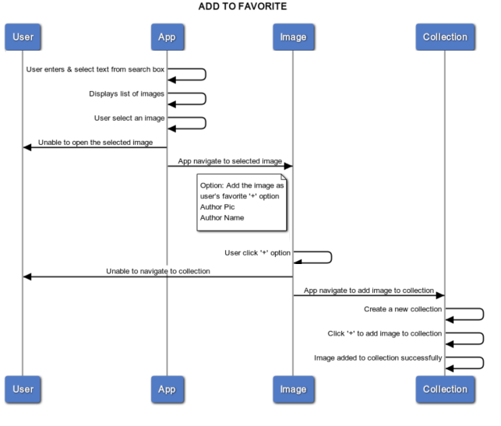

Figure 1: Sequence Diagram – Add to Collections

### Edit and Delete Collections

| **Title** | **Edit and delete collections** |
| --- | --- |
| **Use Case ID** | UIS-0002 |
| **Actors** | User open the application |
| **Description** | This use case shall provide the access to the user to remove an image from collection of the user’s favorite image. |
| **Pre-conditions** | 1. User opens the application |
| **Use case trigger** | 1. Initially, user opens the application 2. User clicks the ‘Your personal menu button’ from the top right corner of the page. |
| **Main flow / Flow of Events** | 1. Once the user clicks the option – ‘Your personal menu button’, the application shall have the following option to choose: Favorites 2. User clicks the ‘Favorites’ option from the above given option. 3. On clicking the ‘Favorite’, the application shall navigate to the next page with the below options to view and choose:   Collections <Tab>   1. User select a collection from the list. 2. On selecting the collection, application shall open all the images which was added in to that collection. 3. Each image shall have the following option to view and choose when user mouse hover on the image:  * Name of the author <Bottom left corner of each image>(Author Name should be clickable) * Round Pic/Image of the author <Bottom left corner of each image> * Download Photo <option> |
| **Sub-flow/Alternate Flows/ Scenarios** | 3a. On clicking the option - ‘Your personal menu button’, application is unable to display the profile and collection tab.  5a. On clicking the 'Favorites' tab, application is unable to display the list of all the collections.  7a. On selecting the collection, application is unable to open all the images which was added in to that collection.  8a. When user mouse hover on an image, application is unable to display the ‘add to favorite’ option.  8b. When user mouse hover on an image, application is unable to display the ‘Name of the author'  8c. When user mouse hover on an image, application is unable to display the ‘Image of the author'  8d. On clicking the ‘download photo’ option, application shall download the photo into the device  9a. When user clicks '’+’ option (Add as favorite)' option, application is unable to navigate to the next page to display the adding options.  9b. 'My first collection' is the default collection provided the application.  9c. User can remove an image from the multiple collections  9d. Go to favorite page from user icon, collection will be listed. On click of collection then redirect to collection details page.  10a. Application provide an option to edit the collection(title & description).  10d. On clicking the ‘delete’ button, the operation should be delete the collection  11a. On clicking the ‘x’ option, the opened image gets closed and application shall navigate to the previous page. |
| **Assumptions** | Images are already stored/saved into the local storage in order to display it from the application. |
| **Post-conditions** | Edit Collection or Image gets successfully removed from the collection. |
| **Status** | Open |
| **Issues** | None |
| **Business Rules** | 1. Application should allow the user to give name to a collection up to 60 characters long. 2. Application should allow the user to give description to a collection up to 60 characters long. 3. Naming a collection should accept alphanumeric and special characters. 4. Naming a collection should accept space in between the name of the collection |

## Module: Favorites

| **Title** | **SHow the lists in favorite page** |
| --- | --- |
| **Use Case ID** | Fav-0001 |
| **Actors** | User open the application |
| **Pre-conditions** | 1. User navigate to the favorite option |
| **Description** | This use case shall enable the user segregate items and stores items in date wise folder |
| **Use case trigger** | 1. Initially, user opens the application 2. User enters the text into the search box. 3. Images are already stored/saved into the database in order to display it from the application. |
| **Main flow / Flow of Events** | 1. Backend application stores item in DB in date wise format 2. User selects option from the web application for arranging items in “Date wise or Date folder wise” 3. Application shall list out all the items in Date wise condition |
| **Sub-flow/Alternate Flows/ Scenarios** | 1a. If the credentials are invalid, server will respond with an error message, which will be displayed to the user in an appropriate error dialog. |
| **Assumptions** | None |
| **Post-conditions** | User is able to segregate item in |
| **Status** | Open |
| **Issues** | None |
| **Business Rules** | 1. All item should store in DB date wise (DDMMYYYY:HHMM) |

#### Sequence Diagram

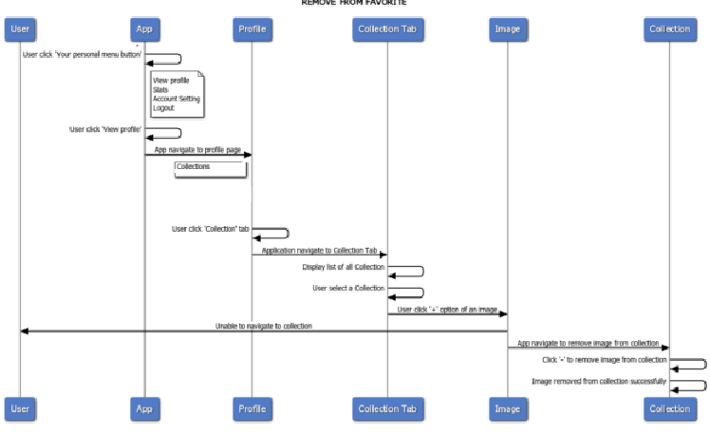

Figure 2: Sequence Diagram – Remove from Collections

## Download Photo

| **Title** | **Download Photo** |
| --- | --- |
| **Use Case ID** | DPH-0001 |
| **Actors** | User with appropriate privilege |
| **Pre-conditions** | 1. By Default, the home screen is displayed |
| **Description** | This use case shall enable the user download a particular photo from the search results |
| **Use case trigger** | 1. By Default, the home screen is displayed 2. The home screen shall have the following options    * Search Photos    * Your Favorite Menu |
| **Main flow / Flow of Events** | 1. User click on favorite from user menu. 2. User redirect to collection tab 3. User click on the collection which displays photos one by one 4. User clicks on photo triggers “Download Photo” 5. The photo shall be downloaded to local “Download” folder |
| **Sub-flow/Alternate Flows/ Scenarios** | None |
| **Assumptions** | None |
| **Post-conditions** | User is able to download the desired photo from the collection |
| **Status** | Open |
| **Issues** | None |
| **Business Rules** | 1. If no results are available for the searched keyword, the page shall display “No photos Found” message 2. Depend on the photos added to the collection displays in favorite |